<Project Name>
<Project Name>

Author:
<Project Name>

Individual Design Approach

Project Partners: Mr. John-Ross Torre, Jacobs Engineering Group Inc.

Demonstrator:
Catherine Hatch

Academic Supervisor:
Dr Sally Male

Group Meeting Day and Time: Friday 12:00 midday

Word Count:2040

Word Limit: 2500

Version 1.3
Revision History
Date | Version | Description | Author
01/04/2017 | 1.0 | Template Creation | Jie Zhang
02/04/2017 | 1.1 | Overhead transmission line literature review | Jie Zhang
03/04/2017 | 1.2 | Individual approach draft completed | Jie Zhang
05/04/2017 | 1.3 | Final Editing | Jie Zhang

Table of Contents
1. Introduction 3
1.1 Project Goals 3
1.2 Purpose 3
1.3 Scope 3
1.4 Definitions, Acronyms, and Abbreviations 3
1.5 References 3
2. Report Structure 4
3. Individual responsibility 4
4. Design Methodology 5
4.1 Software Packages/tools 5
4.2 Requirement Analysis 5
4.3 Factors in Building Transmission Lines 5
4.3.1 Justifications/Recommendations 6
4.4 Components of Overhead Transmission Lines 6
4.4.1 Conductors 6
4.4.2 Ground wires 6
4.4.3 Insulators 6
5. Discussion and Evaluation 6
6. Appendices 6
6.1 Appendix A 6
6.2 Appendix B 6
6.3 Appendix C 6

Individual Design Approach

Introduction

Project Goals
The primary goal of the project is to design a cost-effective method for providing continuous electric power to three pumps in a bore filed located 10km from a mine site near the town of Newman, in Western Australia. The secondary goals include risk analysis, cost calculation, start-up system design, cooling system design, telemetry system power supply design, and equipment protection.

Purpose
The purpose of this document is to detail the base case which designed for supplying sustained electric power to pumps in the remote bore field; also the document will provide justifications and recommendations with regards to the base case.

Scope
The scope of this document includes the summary of individual responsibility and contribution, the requirements related to individual design, and the methods used to meet these requirements.

Definitions, Acronyms, and Abbreviations
Base case: The base case in this project is to use overhead transmission lines to provide continuous electric power to pumps in the bore field.
Newman: Newman is a remote mining town in the north west of Australia. Newman is on land originally owned by the Martu people. Aboriginal occupation of the area dates back 26,000 years, however with the spread of European settlers in the North West in the late 19th century they were driven out of their traditional lands [1].

References
[1] M. Rynne and M. Rynne, "The Martu native title determination," Native Title Newsletter, no. 5, pp. 12-15, 2002.
[2] "DIgSILENT Pacific - Power System Engineering and Software Pages", Digsilent.com.au, 2017. [Online]. Available: https://www.digsilent.com.au/pages/products/powerfactory. [Accessed: 05- Apr- 2017].
[3] "Overhead line Design", Eng.uwi.tt, 2017. [Online]. Available: http://www.eng.uwi.tt/depts/elec/staff/alvin/ee35t/notes/Transmission-Line-Construction.html. [Accessed: 05- Apr- 2017].
[4] T. Gönen, Electrical power transmission system engineering, 1st ed. CRC Press, 2014, pp. 27-28.
[5, 6] Grundfos, "MMS (Data Booklet)," ed, 2008.
[7] M. Farzaneh, S. Farokhi and W. Chisholm, Electrical design of overhead power transmission lines, 1st ed. New York, Chicago, San Francisco, Athens, London, Madrid, Mexico City, Milan, New Delhi, Singapore, Sydney, Toronto: McGraw-Hill Education, 2013, pp. 3-6.
[8-17] T. Gönen, Electrical power transmission system engineering, 1st ed. CRC Press, 2014, pp. 63-68.

Report Structure
The document consists of three main sections: a summary of individual responsibility and contribution in section 3, a detailed analysis of the design method in section 4. Finally justifications and recommendations will be covered in section 5.

Individual Responsibility and Contribution
In the Team Power, the responsibilities of Jie include attending each group meeting, participating in group discussion and brainstorm, sharing relevant document with team members, and helping team with decision making.
Jie has contributed to the theory/method section and the conclusion of requirement analysis report, did research on solar power system and wind power system, checked renewable energy feasibility in Newman, and found relevant literature on solar PV and wind turbine materials. Also, Jie has represented the Team Power to attend a partner meeting held in Jacobs and shared the meeting summary with team member (Appendix B).

Design Methodology
This section will cover the methodology be used in the design approach. Firstly, discuss software packages that would be used in the design; secondly, detail the requirements for the base case design; thirdly, discuss components of overhead transmission lines; finally, a proposal of preliminary base case design.

Software packages/tools
There are several software packages that can be utilized for achieving different purposes of the design, such as electrical network design and simulation, tackling complicated calculation, and estimating cost.

PowerFactory: DIgSILENT PowerFactory is the leading electrical network analysis tool for applications in generation, transmission, distribution and industrial systems [2]. PowerFactory is a powerful tool that could be used to design the power transmission solutions for the base case.
Mathematica/MATLAB: These tools could be useful when solving matrices, simplifying equations, and modelling on the characteristics of transmission lines, such as modelling the relationship between the tension of transmission lines and ambient temperature.
Rawlinsons: This tool could be used when dealing with cost estimation and comparison.

Requirement Analysis
Although the Team Power has already finished the requirement analysis, it is still crucial for each team member to review the requirement list and to make sure that the individual design is consistent with requirements of the project.

According to the Appendix C that the three most significant requirements include that the power generation system should deliver power continuously, the system should produce 90kW per day, and the system should be operated in Newman.
Firstly, the requirement of providing continuous power is not a big issue for the base case when it compares with other renewable energy solutions, because transmission lines can constant supply the required amount of power day and night as long as the electric equipment are well protected and regular maintained; however, the power supplied by solar or wind energy might be constrained by daylight hour and weather.
Secondly, the requirement of producing 90kW per day sets a rough standard for selecting cables, insulators and support structures [3]. A further investigation on materials selection needs to be done in the following section.
Thirdly, the requirement of operating in harsh weather means that the overhead transmission line power system must be suited to operate in adverse environmental conditions, such as high temperature, high wind, heavy rain, lightning strikes and dust. The harsh weather in Newman can be a challenge for protection system design; also it raises the standard for materials selection.

Factors in Building Transmission Lines
Turan stated that there are several factors that need to be considered and established before building transmission lines [4]:
- Voltage level
- Conductor type and size
- Line regulation and voltage control
- Corona and losses
- Proper load flow and system stability
- System protection
- Grounding
- Insulation coordination
- Mechanical design:
- Sag and stress calculations
- Conductor composition
- Conductor spacing
- Insulation and conductor hardware selection
- Structural design:
- Structure types
- Stress calculations
Turan provides the Team Power with a good guideline on designing overhead transmission lines. According to the information offered by Jacobs the three pumps to be used is the Grundfos MMs6000 series. Based on the data booklet [5] of the Grundfos MMs6000 series there are several justifications/recommendations:

Justifications/Recommendations
- The pumps’ operation voltage level is not clear at this stage as they can be operated in a large range of voltage levels, from the minimum voltage 220V to the maximum voltage 500V [6]. It is significant for the Team Power to decide the voltage level before designing transmission lines, thus a further investigation need to be undertook in the further design.
- The distance between the bore field and the mine site is 10km, which is less than 80km, thus the Team Power could adopt the short transmission line model (Appendix A).
- The operational frequency for the pumps is either 50Hz or 60Hz, thus one assumption can be made: the shunt conductance and the shunt admittance of transmission lines are neglected in the design model [7]
- Comparing the current information with the above factors shows that there still have ambiguous points which need to be investigated in the future design.

Components of Overhead Transmission Lines
An overhead line consists of conductors and ground wires, towers, insulators, hardware, and foundations [8].

Conductors
The most commonly used transmission types are the following [9]:
- ACSR (aluminum conductor, steel reinforced)
- ACSR/AW (aluminum conductor, aluminum-clad steel reinforced)
- ACSR-SD (aluminum conductor, steel reinforced/self-damping)
- ACAR (aluminum conductor, allow reinforced)
- AAC-1350 (aluminum alloy conductor composed of 1350 aluminum alloy)
- AAAC-201 (all aluminum alloy conductor composed of 6201 alloy)
Different types of conductor can be used in different situations, for instance the power system has to be operated in corrosive atmospheric conditions then ASCR/AW, ACAR and AAAC-6201 are more suitable compared to other types. Considering the high wind condition in Newman, large and heavy conductors shall be chose due to higher inertia compared with small conductors [10], thus the types of ACSR-SD and AAC-1350 would be considered.

Ground wires
Overhead ground wires also called the shield wires. They are the wires that are installed above the phase conductors (or wires). They used to protect the line from lightning and to even out the ground potential and sometimes even used for low-voltage (LV) communication. The overhead ground wires do not conduct the load current, but they very rapidly conduct the very heavy current of a lightning strike to the ground, through their many grounded connections [11]. The sags of the overhead ground wires must be the same as the sags of the phase conductors [12].
During the design stage, protect the power system from lightning strike is one of the requirements of the project. Thus, the use of overhead ground wires in the transmission line construction can effective avoid lighting strike.

Insulators
An insulator is a material that prevents the flow of an electric current and can be used to support electrical conductors. The function of insulation is to provide for the necessary clearance between the line conductors, between conductors and ground, and between conductors and the pole or tower. Insulators are made of porcelain, glass and fiber glass treated with epoxy resins [13].
The basic types of insulators include pin-type insulator, suspension insulators, and strain insulators. The pin-type insulator is supported on a pin. The pin holds the insulators, and the insulator has the conductor tied to it. However, the pin-type insulators are seldom used on transmission lines having voltages above 44 kV [14]. Suspension insulators consist of a string of interlinking separate disks made of porcelain. A string may consist of many disks depending on the line voltage. For example, as an average, for 115 kV lines, usually 7 disks are used and for 345 kV lines, usually 18 disks are used [15]. When there is a dead end of the line, or there is a corner or a sharp curve, or the line crosses a river, then the line will withstand grate strain. The unit assembly of suspension units arranged to dead-end the conductor of a structure is call strain insulator [16].
As discussed above, the selection of insulator could be confirmed when the characteristics of transmission line are identified. The construction design of the transmission towers and foundations might be provided by Jacobs, if not a further investigation on these topics should be performed.

Discussion and Evaluation
The base case design is important for the whole project design, because it provides the Team Power a basic method for comparing with other renewable solutions in terms of energy cost, energy transmission efficiency and stability. At this stage, the model of the base case has been confirmed, some assumptions have been made for the design, the guideline of designing overhead transmission lines has been created, and the components of transmission lines have been covered. However, there still have many ambiguous areas that need to be clarified in the future design. Thus, the Team Power will continue work together to deliver desire outcomes for the project.

Appendices

Appendix A

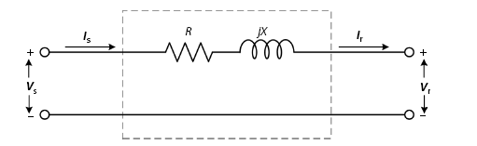
Figure -1- Short distance transmission line diagram [17]

Appendix B
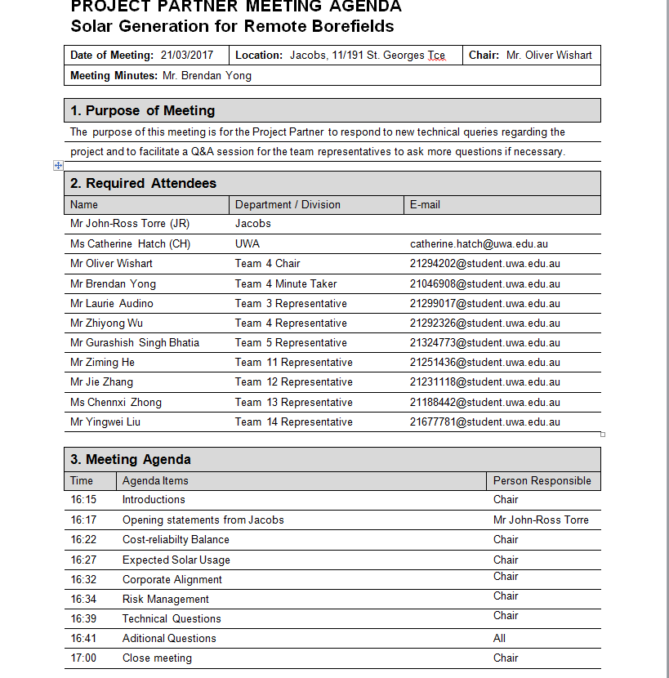
Figure -2- Jabos partner meeting part1
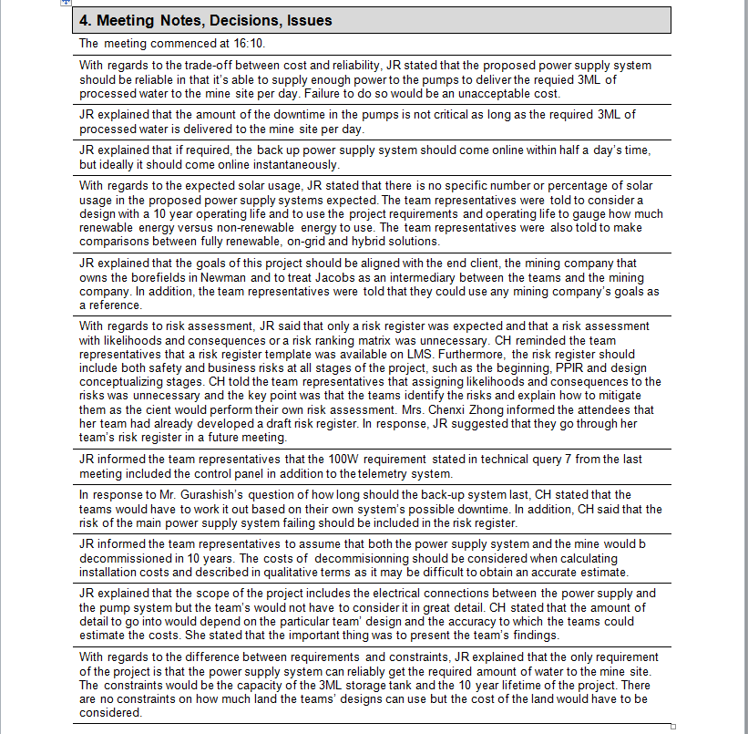
Figure -3- Jabcos partner meeting part 2

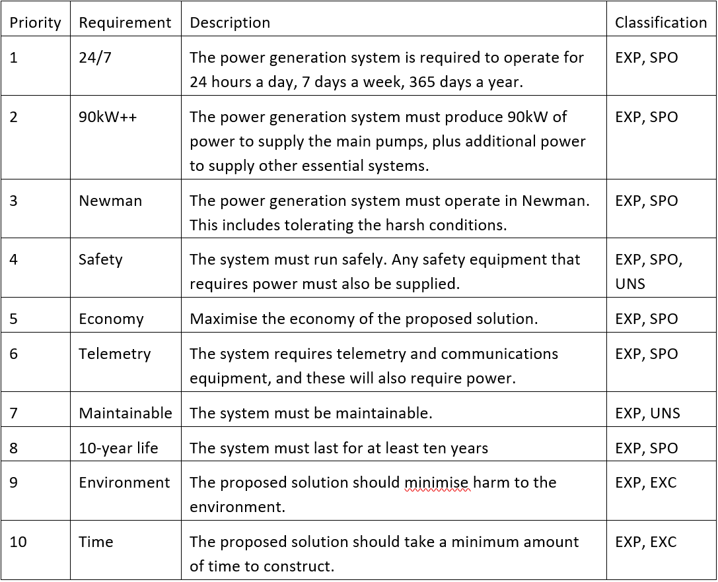
Appendix C

Figure -4- Requirements list for the project

